PROPOSAL FOR DEVELOPMENT (PFD) FORM

Alluvial Mining Lease (AML) Applications

Mining Act 1992 - Sec 42, 52
INSTRUCTIONS
- Information in this form must be either typed or handwritten in block letters
- Where the space provided is insufficient, add a separate sheet on the same format containing the information.

- Details of Applicant/Tenement Holder
(Fill only where appropriate)

- Applicant Information

Name(s) of Applicant (s)
[as on Form 8]
Company Name [if any]
Include IPA registration certificate
Address for Notices
[as on Form 8]
Email Address

Mobile Phone Number (s)

Name of Agent

Email Address

Mobile Phone Number (s)

Other relevant information

*[If AML applicant is an individual, a statutory declaration to say the applicant owns the land must be provided]
**[If ML application is by a company, at least 51% of issued shares or interest is beneficially owned by citizens]

- Tenement Information

Type of Tenement (AML or ML)
Registered Number
Mineral Type
Area (Inclusive) [as on Form 17]*
Sketch Map showing boundaries of area | Insert below or attach as annexure
Statutory Declaration - said area has been marked out | Include as Attachment
Period Sought [as on Form 8]
Nearest town or Landmark (from published maps)
Other relevant information

Tenement Map

- Contract Miner Information

Name of Contract Miner/Developer
Name of Agent(s)/Country Manager
Postal Address
Telephone/Mobile Number
Facsimile Number
Email Address
Current IPA company extracts showing shareholding | Include as Attachments
Date of Registration
Parent Company Country of Incorporation
Nationality of majority shareholding
Does the Contract miner or its Directors/Shareholders have an interest or holding in any other tenements? | If Yes provide details of the Tenements held
Details of Financial Capability
Parent Company guarantees, 6 month bank statements current to date of submission

- Localised Physical Geography
Additional information can be included as attachments
2.1 | Location  Describe the location of the area, which should include transport infrastructure, nearest towns, village and rivers and any special features of the region
2.2 | Climate  Average annual rainfall, temperature and vegetation
2.3 | Soil Structure  Description of soil texture is important to manage soil bailing and environmental impact management such as rehabilitation

- Geology & Land Formation Processes
Additional information can be included as attachments
3.1 | Geology  Describe the brief geology of the lease and the region
3.2 | Geomorphology  Describe the concentration of high density minerals into river/stream channels - high/low energy erosion attributed to streams flowing from rugged terrains. Also faults belts, ranges and structural information must be described
3.3 | Alluvial Deposit  Describe the alluvial deposit with reference to 3.1. Identify whether it is a residual, bench or alluvium derived from actions of streams  (refer to Schedule 1)

- Historical Background
Include additional information as attachments

4.1 | Earliest Alluvial Mining – Describe the historical context of alluvial mining in the region, including how operations were carried out and how much gold was mined during that period.
4.2 | Current Level of Small Scale Operations – If the area is an active alluvial mining region, describe the current mining activities including mining methods applied,, amount of gold has been won, associated events like involvement of gold buyers or outside supported operations etc.

- Prospecting
Include additional information as attachments

5.1 | Sampling Method Applied  Describe the targeted field sampling programme adequately  - sampling processes, upstream samples methods like dredging and drench of all were surface sediment samples  - Record maximum depths reached.  - Sampling programmes preparation.  - Gridding
5.2 | Sampling Methodology  Describe sampling methods bulk or random stream sampling or local knowledge of gold won in the area
5.3 | Sample Analysis  State where the samples were tested and analysed and present results
5.4 | Reserve Estimation  Do a simple reserve estimation based on deposit grade and corresponding number of pan concentrates processed. Must be:  - Plain  - Not interpreted in geological terms such as measured, indicated or inferred terminologies  - The one that best suits the type of occurrences  - Best applied to the configuration of the deposit and mode of deposition. Methods used can be:  - Block  - Polygon  - Cross section  - Inverse Distance

- Mine Plan
Include additional information as attachments

6.1 | Mining Method Selection  Describe the mining method:  - bulk mining,  - sluicing,  - vein mining or a combination  Must be based on the scale of operation.  Provide schematic representation
6.2 | Equipment Selection  Describe the whole equipment selection process. It should be based on:  - deposit type  - convenience  - availability  Mostly skid mounted or fixed trommels and grizzly shaker plants
6.3 | Mining Method  Describe mining method – use of equipment/plant, tailings disposal plan and dilution
6.4 | Gold Recovery Process  Describe the entire process of gold recovery from washing to smelting, plants/equipment and tailings disposal  Provide flow chart schematics/ photographs  (Refer to Schedule 2)

- Financial Modelling
Include additional information as attachments

7.1 | Capital Cost Estimation  Cost of establishment:  Mobile Equipment  Fixed Plant  Contingency | Include Tables as Attachment
7.2 | Operating Cost Estimation  Mining  Processing  Manning  Power  Camp/Admin | Include Tables as Attachment
7.3 | Cash Flow Analysis  Net Present Value NPV, Internal Rate of Return IRR, Pay Back Period PBP, NOPAT, EBITDA | Submit a Cash Flow Analysis
7.4 | Taxation  Types of tax payable
7.5 | Sensitivity Analysis  Describe varying results under different scenarios

- Financial Capability
Include additional information as attachments

8.1 | Cash Resource  - Bank statements, Parent company guarantees  - Seed capital  - Audited Consolidated Financial Statement of Position
8.2 | Contract Miner’s Financing capability (if any)  - Bank statements  - Parent company guarantee  - Audited Financial reports
8.3 | Shareholders  Details of shareholders, directors and their involvement in any other tenements such as ELs, MLs

- Technical Capability
Include names, resumes, references and capability statements of critical management and operational personnel

9.1 | Senior Management  Summary of work experience, positions held, directorship, affiliations
9.2 | Key Operational Personnel  Summary of work experience, positions held, qualifications
9.3 | Onsite Technical Consultants  Summary of work experience, positions held, qualifications
9.4 | External consultants  Record of previous work experiences, qualifications, letter of reference
Additional information should be included as attachments
- Operational Capability
List and describe the inventory of mining and processing equipment and ancillary equipment (water pumps, lighting plants,) make, models, engine hours, either already at hand or in the process of procurement.

10.1 | Loading Equipment  List of all loading, digging equipment such as Excavators, Loaders
10.2 | Hauling Equipment  Listing of all hauling equipment such as Trucks (Rigid and Articulated)
10.3 | Fixed Plant/Processing Equipment  Listing of all equipment:  Trommel, Jigs, Shakers  Concentrators (Knelson, Centrifugal)  Amalgam Barrels  Retorting and smelting equipment  Dolly pots  Shaking tables
10.4 | Auxiliary Equipment  Listing of all equipment  Dozers  Tractors  Water Pumps  Pontoons  Water Canons  Fuel Bowsers
Additional information should be included as attachments

- Community and Regional Socio-Economic Impacts

11.1 | Landowner Structure
11.2 | Community Needs
11.3 | Social and Economic Infrastructure
11.4 | Health Services
11.5 | Education Services
11.6 | Economic Activities
11.7 | Any other activities
Additional information should be included as attachments

- Environment Management Plan

12.1 | Environment Management Strategies  Environmental  Social  Land/Water use  Waste handling  Cultural  Heritage sites
12.2 | Environment Monitoring Plan  Surface Water Quality and Sediment  Biodiversity – terrestrial and aquatic
12.3 | Environment Permits  Applications for:  Waste Discharge  Water Extraction
Additional information should be included as attachments
- Safety Management Plan
Briefly describe the components of a Safety Management Plan applicable to your proposed project
13.1 | Safety Management Strategies
13.2 | Management and Supervision  Competent or Certified person(s)[Manager, Surveyor & Electrician]
13.3 | PPE and Medical Kits  Availability of first aid kits & aiders, and adequate PPEs
13.4 | Chemical and dangerous Goods  Fuel, oil, greases, mercury etc…and other flammable fluids/substances
13.5 | Record Keeping  Employment, Accidents/Incidents, Production, consumables, man-hours etc…
13.7 | Competent Person  Adequate knowledge/skills for the job
13.8 | Fit for Work  Mentally, physically & emotionally well prepared for work
13.9 | Safe and reliable for use  Maintenance schedules, registrations (compliance with other Laws of PNG).
13.10 | Fit for the purpose  Right machine/equipment for the task/work
13.11 | Fatigue Management  Number of hours worked and resting hours of employees and rosters
13.12 | Standard Operating Procedures (SOPs)  Safe Work, Evacuation Plans, Risk Assessments , dangerous goods handling, Emergency Procedures
13.13 | Training and Education  Awareness, signage, posters  Incentives for Safety excellence
Additional information should be included as attachments

- Mine Closure and Rehabilitation Plan
Briefly describe below. Refer to Supplementary Notes

14.1 | Mine Closure and Rehabilitation Plans  This document outlines and discusses mine closure in terms of its socioeconomic impacts and environmental rehabilitation of the project area.  A MCP should include the following, but not limited to:  - Mine Life and Early Mine Closure  - Biophysical Closure  - Flora / Fauna  - Socio-economic Closure  - Cost of Closure  - Employment  - Loss of Business  - Loss of Revenue to local area and PNG  - Decommissioning  - Access and Site roads  - Buildings  - Waste – oil, grease, waste tyres, paper, timber, intractable wastes  - Riverine Siltation – water quality monitoring  - Open Pits – landscaped, contoured, re-vegetated  - Rehabilitation Plan  - Post Closure Monitoring | Submit a separate Mine Closure and Rehabilitation Plan

Supplementary Information

All applications should include as attachments the following (but not limited to):

- Schematic Plant design and operational parameters
- Typical Processing Flow Chart (Schedule 2)
- Site Layout Plan (Schedule 3)
- Production Forecast for five years
- A Cash Flow Analysis
- Mercury Handling Procedures (if using mercury)
- Organisational Structure
All mechanised alluvial operations are required to provide detailed submissions for:
- Environment Management Plan (as detailed in 11)
- Safety Management Plan (as detailed in 12)
- Mine Closure and Rehabilitation Plan (As detailed in 13)
Included with their Proposal for Development (PFD)
Environment Permit
As defined in the Environment (Prescribed Activities) Regulation 2002, most operations can be categorised as Level2, Category B activity where it is defined in category number 7.2 as:
“Mechanised Mining on a Mining Lease issued under the Mining Act 1992 involving non-chemical processing of more than 50,000 tonnes per annum”

- Compensation Agreement – an agreement between the tenement holder and land holders whereby compensation is payable to land holders of the land the subject of the tenement for all loss and damage suffered by them from the mining activities.
- Tribute Agreement – if mining will be done by a contract miner

Different Types of Deposits – Notes to Schedule 1

There are many different places gold could be placed, such as a residual, alluvial, and a bench deposit.

Residual
Residual deposits are more common where there has been weathering on rocks and where there hasn’t been water. They are deposits which have not been washed away yet or been moved. The residual usually lies at the site of the lode. This type of deposit undergoes rock weathering

Alluvial
Alluvial or eluvial deposits sometimes have the largest gold deposit and are very common. This deposit is created when a force of nature moves or washes the gold away, but it doesn’t go into a stream bed. It contains pieces of ore that have been washed away from the lode. Alluvial deposits are the most common type of placer gold. This type of deposit occurs mostly in valleys

Bench
Bench deposits are created when gold reaches a stream bed. Gold accumulations in an old stream bed that are high are called bench deposits. They can be found on higher slopes that drain into valleys. Dry stream beds (benches) can be situated far from other water sources and can sometimes be found on mountain tops. Today, many miners focus their activities on bench deposits.

Schedule 1: Alluvial Deposit Types

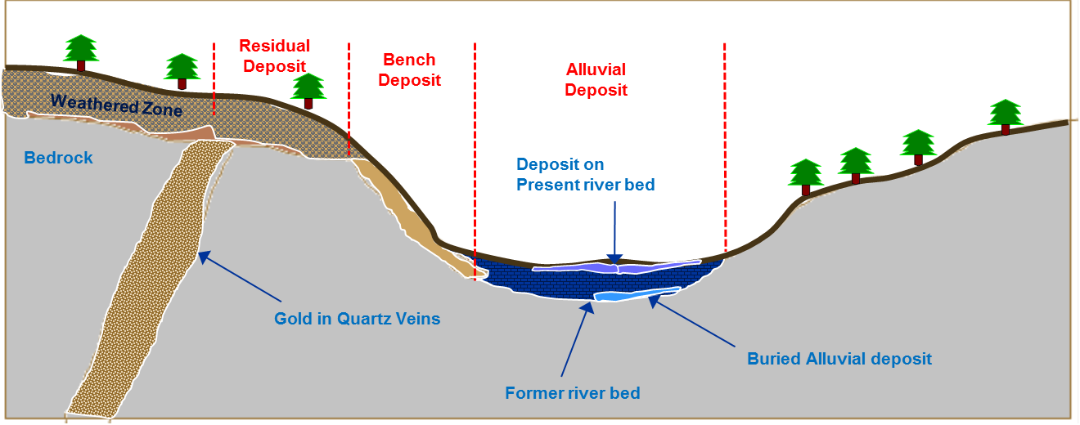

Schedule 2: Typical Process Flow Diagram

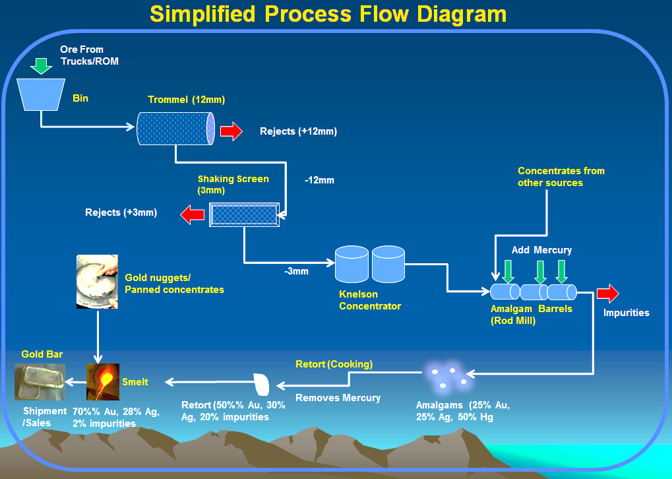
Schedule 3: Typical Site Layout Plan
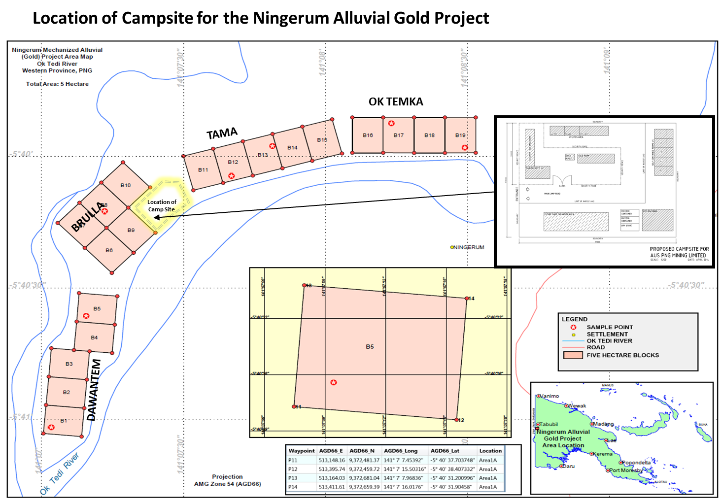
(Courtesy of Tie O Die Ltd, Ningerum)

