Geotourism: an emerging geoscience field to promote environmental conservation and sustainability, educational and tourism opportunities within Papua New Guinea and the Pacific Islands

Moira Lunge^{1 *} and Dulcie Saroa¹
¹ Geological Survey Division, Mineral Resources Authority, P O Box 1906, Port Moresby 121, NCD, Papua New Guinea

* Corresponding Author: mlunge@mra.gov.pg

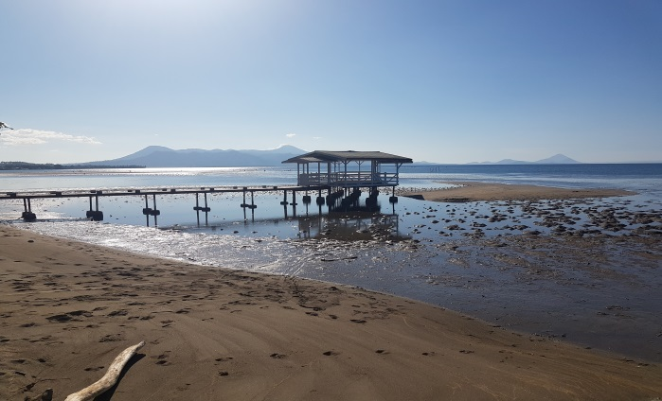
The dynamic landscapes that hosts Papua New Guinea’s rich oil, gas and mineral fields is a result of its unique geological heritage at the heart of the collision between the continental Australian and oceanic Pacific plates. Despite its promotion as the land of a million different stories which are reflections of the diverse cultures, an appreciation of the landscape development and geological understanding has never been part of its conservation approach and tourism promotion.

Known as the tourism of geology and landscape, geo-tourism includes the biotic characteristics of the landscape such as flora and fauna (biodiversity), cultural features, non-living and built areas while emphasizing more on the origins and significance of the geographical features or geo-sites. It is the geological landscapes that shape communities and its residents and how they live, hence, an appreciation for science within host communities is created through geo-tourism initiatives.

Figure 1: Pacific Islands Volcanic panoramic view; a tourism
potential.

Encompassing the global aims of green climate, geo-tourism initiative resolves this locally through a geo-conservation
strategy within the environmental conservation approach and as geohazard awareness strategy for development plans. Geotourism can also be incorporated as a mine closure and rehabilitation measure to promote environmental sustainability while preserving certain mining landscapes for tourism engagement and geoscience education.

While Pacific Tourism Organisation, Pacific Community and United Nations Educational Scientific and Cultural Organisation have partnered to support tourism recovery with the establishment of geoparks on existing ecotourism sites in Fiji, Tuvalu, Samoa and Vanuatu, Papua New Guinea through the Mineral Resources Authority’s Geological Survey Division has formed domestic collaborations to develop geotourism products ranging from tourism attractions and educational opportunities, including geoscience research and conservation, for better appreciation of our environment.

Key words: Geosciences, Geotourism, Geoconservation, Papua New Guinea, Pacific

References

Hall R, 2002. Cenozoic geological and plate tectonic evolution of Southeast Asia and the South-west Pacific: computer- based reconstructions, model and animations. Journal of Asian Earth Sciences, v 20, p 353-431.
Deer WA, Howie RA, Zussman J, 1962. Rock-Forming Minerals, Volume l. Longmans, Green & Co., London (UK), 371 p.

